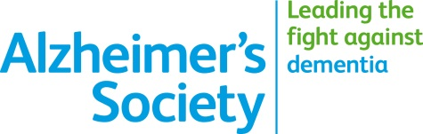

Volunteer and help bring a smile to someone’s face...

...our volunteer befrienders do this every day
Living with dementia can be isolating. Alzheimer’s Society volunteer befrienders make a difference. Find out more about volunteering with us by having a chat with Laura or Lisa on 01296 331722 or emailing bucksbefriending@alzheimers.org.uk

We’d love to hear from you.

Alzheimers.org.uk
Alzheimer’s Society operates in England, Wales and Northern Ireland.
Registered charity number 296645.

